Packet Sniffer and Network Traffic Analyzer Using Python & Scapy

Report

Title Page
Project Title: Packet Sniffer and Network Traffic Analyzer Using Python & Scapy
Course: Computer Networks
Project Type: Semester Project Report
Language: Python
Libraries Used: Scapy, CSV, Datetime, Matplotlib
Submitted By: _M.Shahnam, Syed Burhan, Zakir Khan.
CMS ID: 69256, 69184, 69205
Instructor: Miss. Poma Panezai
Department: Data Science
University: Buitems
Submission Date: 13 july 2026

Introduction
Computer networks continuously exchange large amounts of data in the form of packets. Every activity performed on the Internet, such as browsing websites, sending emails, streaming videos, downloading files, or communicating through messaging applications, involves the transmission of network packets. Understanding these packets is essential for network administrators, cybersecurity professionals, and students studying computer networking.
A packet sniffer is a software application that captures network packets travelling through a network interface and displays useful information about them. Packet analysis helps identify communication patterns, diagnose network problems, monitor traffic, and understand how different network protocols operate.
The objective of this project was to develop a packet sniffer using Python and the Scapy library. Rather than simply capturing packets, the project focused on understanding every stage of implementation, beginning with learning Python programming, installing the required libraries, understanding networking protocols, extracting packet information, organizing the code into reusable functions, exporting captured information into CSV files, generating protocol statistics, performing packet filtering, and analyzing frequently occurring IP addresses and port numbers.
Throughout development, several debugging sessions were required to solve issues related to Python environments, missing protocol layers, CSV generation, logical conditions, and statistical calculations. These challenges improved both programming and networking knowledge while producing a functional packet analyzer capable of capturing and analyzing live network traffic.

Objectives
The main objectives of this project are:
- To understand the fundamentals of Python programming.
- To learn packet sniffing using the Scapy library.
- To capture live network packets from the local machine.
- To identify common network protocols such as TCP, UDP, ICMP, ARP, IPv4, and IPv6.
- To extract source and destination IP addresses.
- To extract source and destination port numbers where applicable.
- To determine packet size and capture time.
- To display packet information in a readable format.
- To export captured packet information into a CSV file.
- To generate protocol distribution statistics.
- To calculate packet size statistics.
- To filter packets according to protocol.
- To identify the most frequently occurring IP addresses and port numbers.
- To improve programming skills through debugging and code refactoring.

Tools & Technologies
The following tools and technologies were used during the development of this project.

Programming Language
- Python 3
Python was selected because of its simple syntax, large number of networking libraries, and ease of development.

Development Environment
- Visual Studio Code (VS Code)
VS Code was used for writing, debugging, and executing the Python program.

Packet Capture Library
- Scapy
Scapy is a powerful Python library that provides functions for capturing, analyzing, and manipulating network packets.

Python Modules
The project used several built-in Python modules including:
- csv
- datetime
- collections
- os

Data Storage
Captured packets were exported into CSV format for later analysis using spreadsheet software.

Data Visualization
Matplotlib was selected for generating graphical representations of packet statistics.

Operating System
- Microsoft Windows

Methodology
The development process followed an incremental approach. Each feature was implemented only after understanding the previous one completely.

1. Learning Python
The project began by studying Python fundamentals before writing networking code. Topics included:
- Variables
- Data types
- Loops
- Conditional statements
- Functions
- Object-oriented programming
- Constructors
- self keyword
- Modules
- Import statements
- Return values
- Multiple return values
- Tuple unpacking
This knowledge provided the foundation required for later implementation.

2. Installing Scapy
The Scapy library was installed using pip.
Initially, the project encountered a ModuleNotFoundError because Scapy had been installed for a different Python interpreter than the one selected in Visual Studio Code.
The issue was solved by:
- Checking Python version
- Verifying installed packages
- Selecting the correct interpreter
- Installing Scapy in the active environment

3. Capturing Packets
After installation, Scapy’s sniff() function was used.
Initially, only six packets were captured to simplify testing and debugging.
This confirmed that packet capturing worked correctly.

4. Understanding Packet Structure
Each captured packet was inspected using:
packet.show()
This displayed all available packet fields including:
- Ethernet Header
- IP Header
- TCP Header
- UDP Header
- ICMP Header
- ARP Fields
- Checksums
- Flags
- Payload
Studying packet structures helped identify the fields required by the project.

5. Extracting Packet Information
After understanding packet structures, individual fields were extracted.
The program successfully retrieved:
- Protocol
- Source IP
- Destination IP
- Source Port
- Destination Port
- Packet Length
- Capture Time

6. Handling Different Protocols
Not every packet contains the same protocol layers.
The program therefore used conditional statements together with packet.haslayer() to safely determine whether TCP, UDP, IPv4, IPv6, ICMP, or ARP layers existed before attempting to access their fields.
This prevented runtime exceptions.

7. Refactoring
Initially, the program contained repeated print statements.
To improve readability, reusable functions were created.
Functions included:
- Protocol()
- address()
- ports()
- capturetime()
- length()
- display_packet()
This significantly reduced duplicated code.

8. CSV Export
The extracted packet information was exported into CSV format.
The CSV file stores:
- Protocol
- Source IP
- Destination IP
- Source Port
- Destination Port
- Packet Size
- Capture Time
The generated CSV can easily be opened in Microsoft Excel.

9. Statistical Analysis
Additional functionality was implemented for analyzing captured traffic.
Statistics include:
- Total packets
- TCP packets
- UDP packets
- ICMP packets
- ARP packets
- Largest packet
- Smallest packet
- Average packet size

10. Packet Filtering
Users can filter captured packets by protocol.
Supported filters include:
- TCP
- UDP
- ICMP
- ARP
Only packets matching the selected protocol are displayed.

11. Frequency Analysis
Python dictionaries were used to count:
- Most frequent source IP
- Most frequent destination IP
- Most frequent source port
- Most frequent destination port
This provided useful information about communication patterns.

Implementation
The implementation phase consisted of several development stages.

Learning Networking Concepts
Before implementing the analyzer, the structures of TCP, UDP, ICMP, and ARP packets were studied in detail.
Each protocol contains different fields.
Understanding these differences was essential because not every packet contains source and destination ports.

Packet Capture
Packet capture was implemented using the Scapy library.
The application continuously captures packets and stores them for processing.
Initially, fixed packet counts were used to simplify testing.
Later versions supported larger captures.

Packet Processing
Every packet is processed individually.
The analyzer determines:
- Protocol type
- Source address
- Destination address
- Port numbers
- Packet size
- Capture timestamp
IPv4 and IPv6 packets are both supported.

Timestamp Formatting
Scapy stores capture time as Unix timestamps.
Python’s datetime module converts these values into human-readable format.
Example:
2026-07-10 14:35:28
This format is easier to understand and suitable for CSV storage.

Error Handling
Several implementation issues were encountered.

IPv4/IPv6 Issue
Attempting to access IPv4 information from IPv6 packets caused exceptions.
Solution:
Use packet.haslayer(IP) and packet.haslayer(IPv6) before extracting addresses.

TCP/UDP Port Issue
ARP and ICMP packets do not contain ports.
The solution was to retrieve ports only when TCP or UDP layers existed.

CSV File Location
Initially, CSV files appeared missing.
The issue was caused by Visual Studio Code’s working directory.
Understanding relative and absolute paths solved the problem.

CSV Header
Headers were accidentally written repeatedly.
The header-writing code was moved outside the processing loop.

Average Packet Size
Only some packets were contributing to total size.
The algorithm was corrected so every packet contributed to the final average.

Packet Filtering
Initially, “Not Found” appeared after every packet.
A Boolean flag named found was introduced.
The message is now printed only once after the search finishes.

Protocol Statistics
Counters were maintained for:
- TCP
- UDP
- ICMP
- ARP
These counters provide an overview of protocol distribution.

Packet Size Statistics
The analyzer calculates:
- Largest packet
- Smallest packet
- Total bytes captured
- Average packet size
These values help understand network traffic characteristics.

Frequency Analysis
Python dictionaries were used for counting occurrences.
Separate dictionaries were maintained for:
- Source IPs
- Destination IPs
- Source Ports
- Destination Ports
The program identifies the entries with the highest occurrence counts.

Code Organization
The final implementation uses modular programming.
Separate reusable functions perform specific tasks, making the code easier to understand, debug, and maintain.

Results & Screenshots
The completed packet analyzer successfully captures and analyzes live network traffic.
The application correctly identifies multiple protocols including TCP, UDP, ICMP, ARP, IPv4, and IPv6.
Packet information such as source IP address, destination IP address, source port, destination port, packet size, protocol name, and capture time is displayed correctly on the console.
The analyzer also exports all captured information into a structured CSV file that can be opened in Microsoft Excel for further analysis.
Statistical analysis successfully calculates protocol distribution, largest packet size, smallest packet size, average packet size, total bytes captured, and total packet count. Packet filtering also works correctly by displaying only packets matching the selected protocol.
Dictionary-based frequency analysis successfully identifies the most commonly occurring IP addresses and port numbers.

Suggested Screenshots
Insert the following screenshots in the final report:
- Python program running successfully.
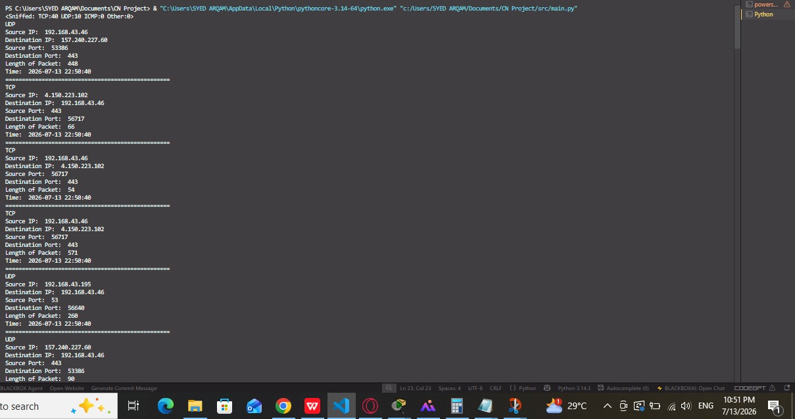
- Live packet capture in the console.
- Display of TCP, UDP, ICMP, and ARP packets.
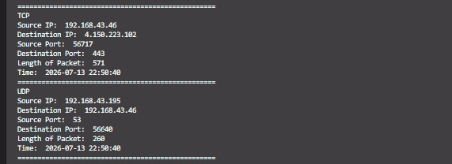
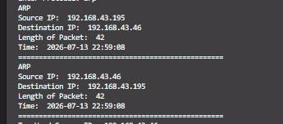

- CSV file containing exported packet data.
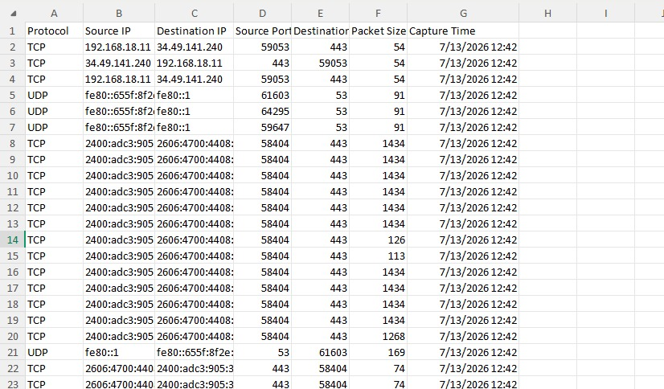
- Protocol statistics displayed after execution.
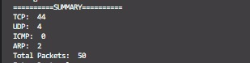
- Packet size statistics.
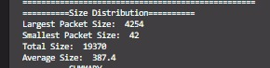
7.Packet filtering output.
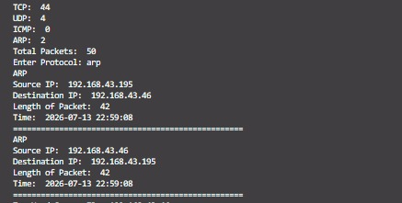
8.Frequency analysis output.
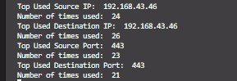
9.Matplotlib graphs showing protocol distribution and packet statistics (if implemented).
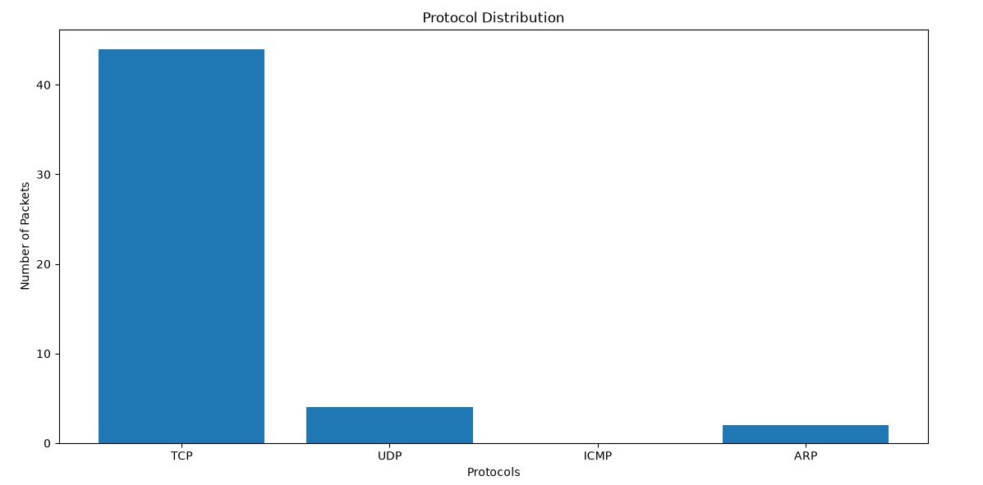
10.Project folder structure containing source code, CSV file, README, and requirements.txt.
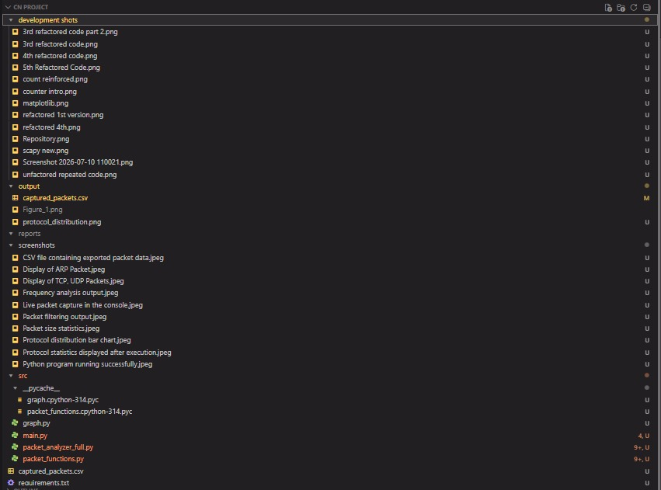

Project Deliverables
• GitHub repository containing the complete project.
• Modular source code (main.py, packet_functions.py, graph.py).
• Protocol distribution graph generated using Matplotlib.
• Frequency analysis of IP addresses and port numbers.
• Protocol distribution and packet size statistics.
• Protocol filtering functionality.
• CSV export of captured packet information.
• Packet size and timestamp analysis.
• Extraction of source and destination port numbers.
• Extraction of source and destination IP addresses.
• Identification of TCP, UDP, ICMP, ARP, IPv4, and IPv6 protocols.
• Live packet capturing using the Scapy library.
• Python-based Packet Sniffer and Network Traffic Analyzer.

Conclusion
The Packet Sniffer and Network Traffic Analyzer project successfully achieved its objectives by implementing a complete packet capturing and analysis system using Python and Scapy. The project not only demonstrated how network packets can be captured in real time but also provided practical experience in Python programming, debugging, software design, and networking concepts.
During development, several challenges such as Python interpreter configuration, protocol layer detection, CSV generation, logical errors, and statistical calculations were encountered and successfully resolved. These debugging experiences significantly improved understanding of both programming and computer networking.
The final application captures live packets, identifies multiple protocols, extracts important packet information, records capture timestamps, calculates packet sizes, exports data into CSV format, generates protocol statistics, filters packets based on protocol type, and performs frequency analysis of IP addresses and port numbers. The modular design of the software also makes future enhancements easier.
Possible future improvements include graphical visualization using Matplotlib, packet searching based on IP addresses, support for additional protocols, real-time dashboards, graphical user interface (GUI) integration, and advanced packet filtering using Berkeley Packet Filters (BPF). Overall, the project provided valuable practical knowledge and established a strong foundation for further work in network analysis and cybersecurity.

THE END

